NATIONAL AVIATION UNIVERSITY

FACULTY OF CYBERSECURITY, COMPUTER AND SOFTWARE ENGINEERING

SOFTWARE ENGINEERING DEPARTMENT

**Laboratory Work № 3**

**“Basic elements of Graphical User Interface”**

Variant № 7

Prepared by: Andrii Vynarchuk Student of SE-226A

Checked by: Oleksandr Shapoval

Kyiv 2022

***Goal:*** *familiarize yourself with basic elements of every Graphical User Interface and explore their creation.*

# Execution Order

1. Learn basic elements of GUI.
2. Create an interface as shown in Fig 1.1 using any of the technology stack. You can create nterface for desktop (Windows, Linux or MacOS), web or mobile (iOS, Android) application. Requirements to the interface:
   * At the top of the form there is the Enter a Message editing field for entering a message, which will be displayed in a pop-up window when the Show Message button is clicked.
   * Below are two buttons that fill the editing field with two different default messages ‘Default Message 1’ button shows message ‘This is my default message’, and ‘Default Messages 2’ button shows message ‘This is another default message’.
   * Below, the drop-down list contains a list of actions that will be executed within this application:
     + ‘Clear field’ will clear edit field above
     + ‘Copy text’ will copy message from edit field above to buffer
     + ‘Paste text’ will paste any data from buffer to edit field above

Selecting a row from the list and pressing the ‘Execute’ button will perform the action.

* + Next are two groups of checkboxes that relate to the controls at the top. The left set ofnEnable Actions checkboxes enables or disables each group of controls above. The right set of Show Actions checkboxes makes each group of controls hidden or not.
  + The Exit button closes the application (for desktop or mobile apps) or closes the tab (for web app)

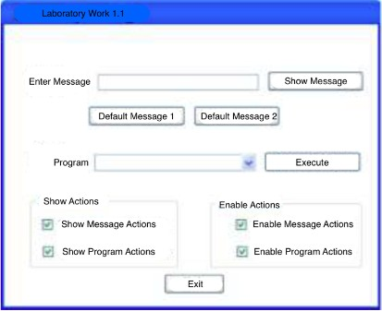

Fig. 1.1 Interface Prototype

1. Add the required code to the ‘Default Message 1’ and ‘Default Message 2’ buttons so that the text field acquires the value ‘This is my default message’ and ‘This is another default message’ correspondingly.
2. Add the required code to enable or disable (show or hide) controls on the interface.
3. Extend the code so that the user can add its own commands to drop-down list.
4. Add to the created interface the execution of the function according to your variant

# Individual task by variant



**Project code**

The project is written in JavaScript library React and other JavaScript libraries. Project has dynamic typification (without TypeScript ).

The main concept of React demands separation, so the project architecture is divided and large enough to take it into this report. So source code is at my [Github](https://github.com/De-Real/HCI-lab1) [repository](https://github.com/De-Real/HCI-lab1) and here I leave some parts of it. The hosted example of [web application](https://de-real.github.io/HCI-lab1/) [can be found using this link](https://de-real.github.io/HCI-lab1/).

1. Project architecture (left) and App component (right).

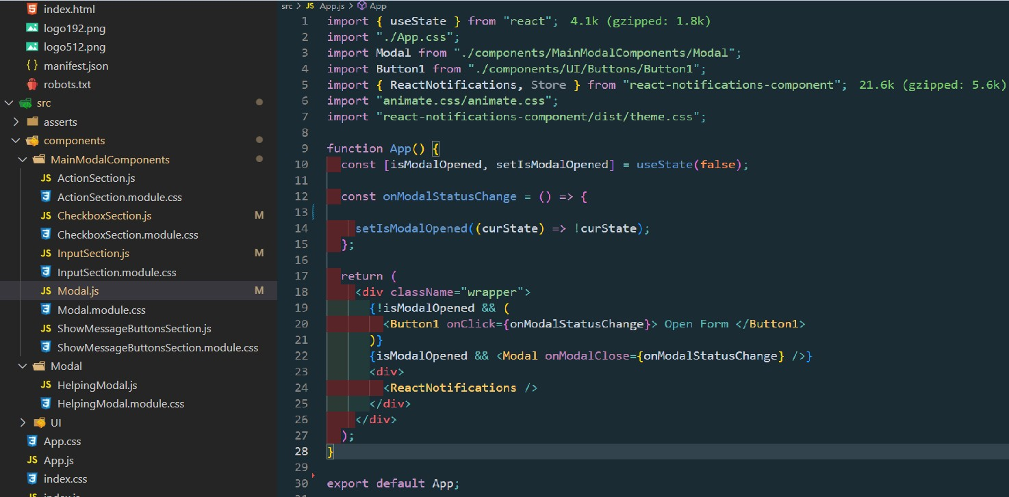

1. Some part of main Modal (the biggest and most loaded component)

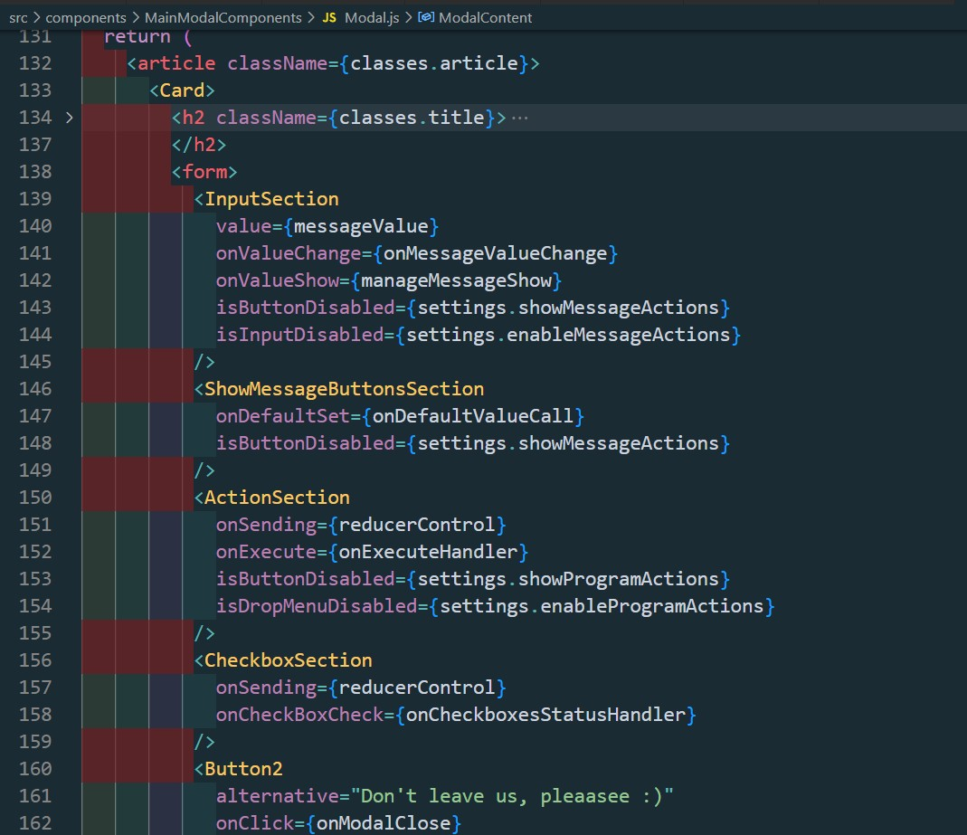

1. Project execution

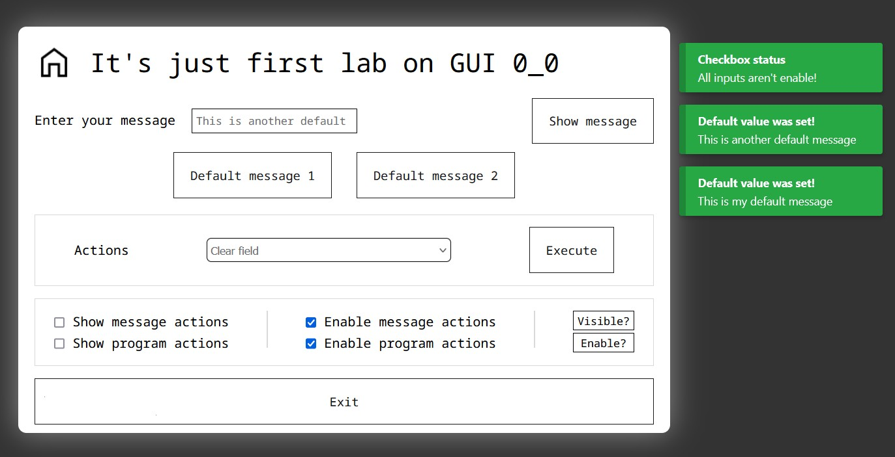

Links repeat ( if links above doesn’t work):

GitHub Source Code: https://github.com/De-Real/HCI-lab1 Deployment web app: <https://de-real.github.io/HCI-lab1/>

**Conclusions.** *I got familiarization of myself with basic elements of every Graphical User Interface and explore their creation.*